LKSN 2025

TEKNOLOGI
DESAIN GRAFIS

Module 2 (EN)
Editorial Design

LKS NASIONAL
JULY 2025

Submitted by:
Luky Wiranda

Instructions for Competitor

- Create a folder named Competitor Number_Your Name
  - The folder must contain all final files in the format specified in the technical specification.
- You must use all the text provided in the appendix for each tasks as specified, adding or subtracting text from the appendix is ​​not allowed.
- You may use the image/photo assets that have been provided.
- You may use create raster element or additional vector provided.
- You are not permitted to use images/photos from internet or from sources other than provided.

Example of arranging folders on a Competitor’s computer:
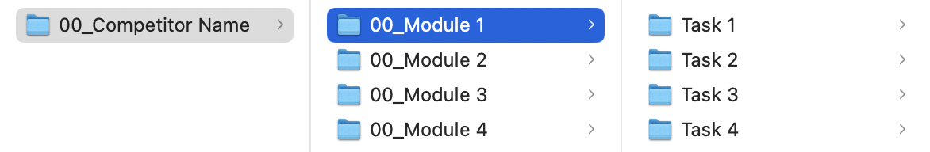

Module Folder
Module 2

Project Description and Tasks

This module consists of 2 (TWO) tasks that you have to do. You are not allowed to do outside the time limit that has been given.

Briefing of the Project
Brand Name : Kertasiana
Business : Paper supplies

Introduction
Kertasiana, founded in 1995 by Kris Ertandas Indro, is an independent company based in Bandung that focuses on providing high-quality paper for designers, brands, and publishers. The company highlights various paper characteristics such as engaging textures, rich colors, and a wide range of choices to inspire creativity. Kertasiana emphasizes the importance of paper that stimulates the senses and supports a creative ecological approach.

Kertasiana excels not only in product quality but also in its commitment to the community and the planet. They established the Kertasiana Charitable Trust to support young people across West Java in pursuing careers in the creative industry. In addition, they are proud to be a certified B Corp, practicing a zero-waste-to-landfill policy and reducing CO₂ emissions from 760 tons (in 2018) to 200 tons per year, with a target of reaching net-zero at their facilities by 2027. Kertasiana also offers fully recyclable paper, strengthening their reputation as a sustainable paper provider.

Description of the Project
You are assigned to design a logo identity and section of a promotional booklet to help the company market their brand and products.

Target Audience
Audience : Male 50% / Female 50%
Age Range : 19-45 years old
Social Class : Middle-up class with income Rp5.500.000 and above
General Behavior : Work on graphic design industries (creative director, art director, graphic designer), graphic design students.

Task 1: Vector Logo

Objective
Create a vector logo for Kertasiana’s brand identity. This logo will be implemented into the company profile booklet that you will create.

Requirement
- Design only the logotype
- The logotype must use Sans Serif
- Use only 2 (TWO) colours and must include this colour: C26 M0 Y100 K0
- Text must include: Kertasiana
- You may use uppercase or lowercase for the logo

Technical Specifications
Dimension : A4 – 297 mm x 210 mm (Landscape)
Color Mode : CMYK with ONLY 2 (TWO) colours
and must include this colour: C26 M0 Y100 K0
Design element : Only logotype and must use Sans Serif.

Working File Format : AI
Final File Format : PDF

Folder Name : Competitor Number_Module 2
Sub Folder Name : Task 1
File Name : Competitor Number_Module 2_Logo

Provide
Folder & file names as specified in "Instructions for Competitor". Only links & files from this folder will be marked.

1 x PDF – vector and text outlined
1 x AI – vector and text outlined

Task 2: Booklet

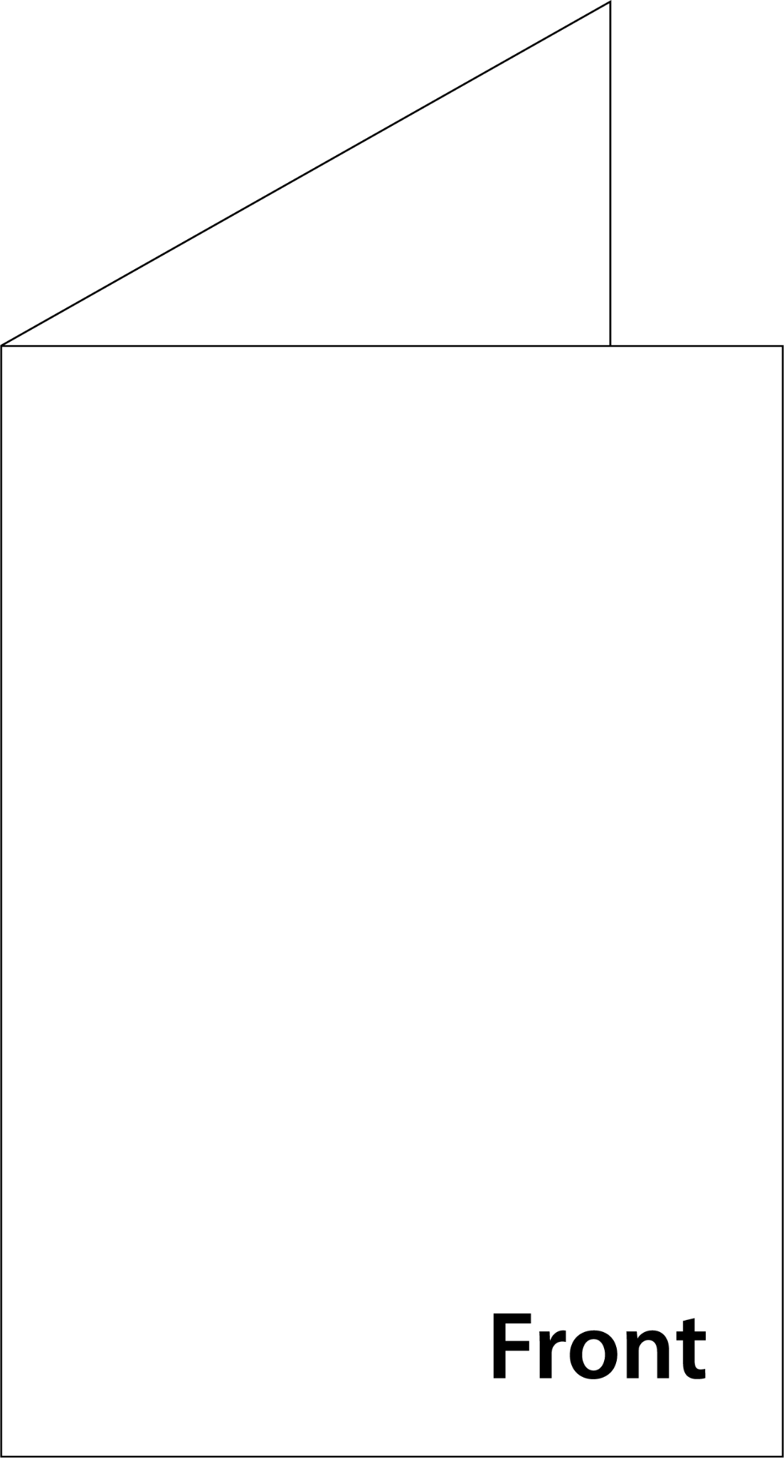
Objective
Create a company profile booklet for Kertasiana, ensuring the layout is efficient, the content remains readable, and the overall design retains a strong sense of aesthetics.

Requirement
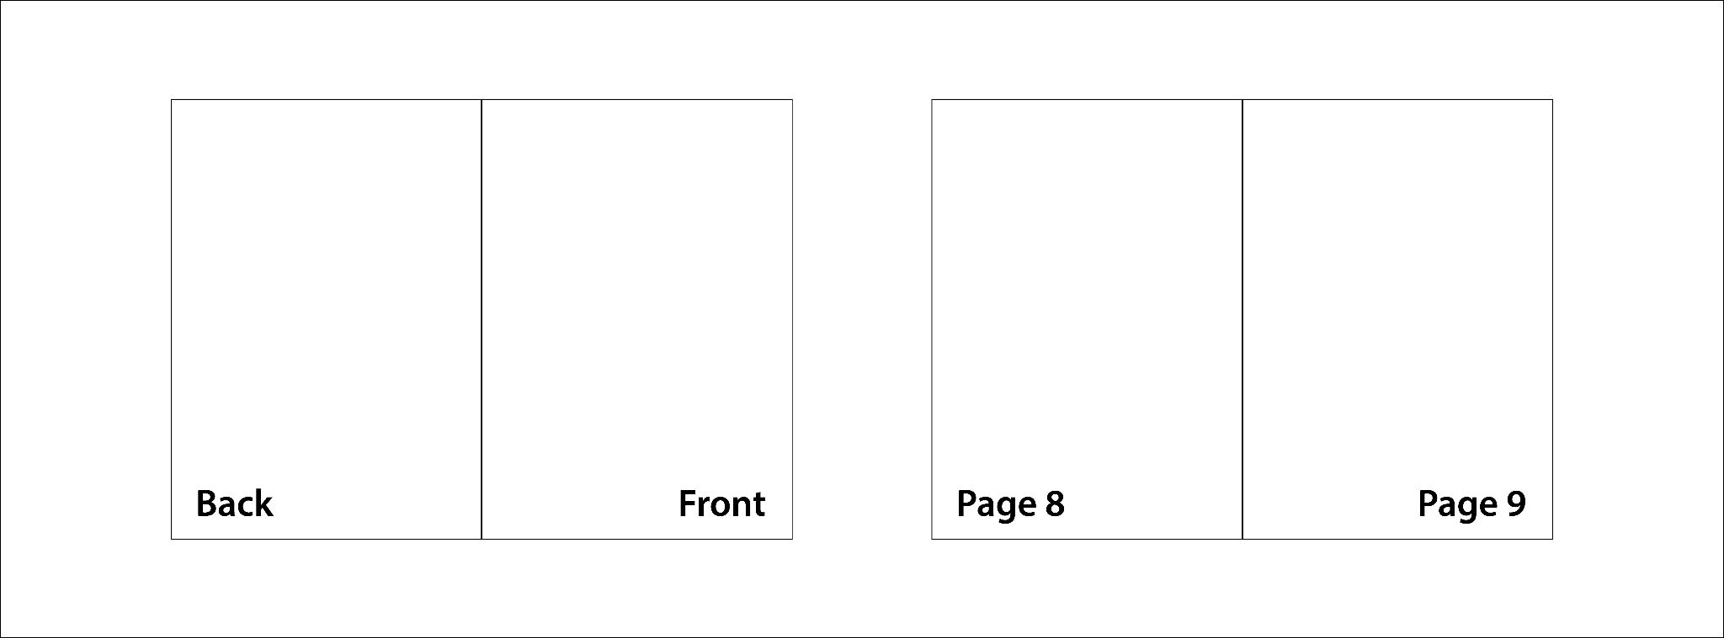
Sample booklet page layout.

Booklet Design
- Create outer and inner (only page 8 & 9) booklet
- You must include text from Appendix: Module_2-Appendix_1-Text.docx
- The typography should maintain readability while also contributing to the Booklet’s aesthetic appeal
- You may create your own graphic elements or illustrations
- You may alternate the text to uppercase or lowercase

Outer Booklet – Front Cover
- You must include:
  - Kertasiana logo from Task 1
  - 1 (ONE) image – you may alternate the image
  - Text from Appendix: Module_2-Appendix_1-Text.docx
  - Any other graphic elements or illustrations you may need

Outer Booklet – Back Cover
- You must include:
  - Kertasiana logo from Task 1
  - FSC Logo from folder Appendix 3 - FSC & Barcode – you may alternate the colour
  - Barcode – with only 100% Black colour
  - Text from Appendix: Module_2-Appendix_1-Text.docx
  - Any other graphic elements, images, or illustrations you may need

Inner Booklet – Page Left (Page 8)
- You must include:
  - 2 (TWO) images or more – you may alternate the image
  - Paragraph style: “Title”, “Body Text”, and “Caption” – you may add other paragraph styles
  - Header and Footer
  - Text from Appendix: Module_2-Appendix_1-Text.docx
  - Any other graphic elements or illustrations you may need

Inner Booklet – Page Right (Page 9)
- You must include:
  - Only 1 (ONE) image – you may alternate the image
  - Paragraph style: “Title”, “Body Text”, and “Caption” – you may add other paragraph styles
  - Header and Footer
  - All logos from folder Appendix 4 - Companies
  - Text from Appendix: Module_2-Appendix_1-Text.docx
  - Any other graphic elements or illustrations you may need

Technical Specifications
Dimension : 148 mm x 210 mm (Portrait) - Closed
296 mm x 210 mm (Landscape) - Opened
Image Resolution : 250-350 ppi
Color Mode : CMYK
Bleed : 5 mm
Paragraph Styles : Must include “Title”, “Body Text”, and “Caption”.
You may add other paragraph styles

Working File Format : INDD
Final File Format : PDF

Folder Name : Competitor Number_Module 2
Sub Folder Name : Task 2
File Name : Competitor Number_Module 2_Booklet

Provide
Folder & file names as specified in "Instructions for Competitor". Only links & files from this folder will be marked.

1 x Packaged folder, with consist:
- 1 x .INDD
- 1 x .PDF with PDF/X-4:2010 ready
- Fonts and images collected

